This template can be used for multiple purposes:

by:

* It enables schools to effectively plan their use of the Primary PE and sport premium
* It helps schools to meet the requirements (as set out in guidance) to publish information on their Primary PE and sport premium
* It will be an effective document to support Ofsted inspections enabling schools to evidence progress in Physical Education (PE) and evidence swimming attainment, which forms part of the PE National Curriculum. We would recommend schools consider

the Intent, Implementation and Impact of any spend, as examined within the Education Inspection Framework.

It is important that your grant is used effectively and based on school need.

Schools must use the funding to make **additional and sustainable**

**improvements** to the quality of the PE, School Sport and Physical Activity (PESSPA)

they offer. This means that you should use the Primary PE and sport premium to:

* Build capacity and capability within the school to ensure that improvements made now will benefit pupils joining the school in future years
* Develop or add to the PESSPA activities that your school already offers.

**The Primary PE and sport premium should not be used to fund capital spend projects; the school’s core budget should fund these. Further detail on capital expenditure can be found in the updated** [**Primary PE and sport premium guidance**](https://www.gov.uk/guidance/pe-and-sport-premium-for-primary-schools)**.**

The Primary PE and sport premium guidance, outlines 5 key priorities that funding should be used towards. It is not

necessary that spending has to meet all the key priorities, you should select the priorities that you aim to use any funding towards.

Although completing this template is not a requirement for schools, schools are required to publish details of how they spend this funding. Schools must also outline what the impact this funding has had on pupils’ PE and sport participation and attainment and how any spending will be sustainable in the future. **All funding must be spent by 31st July 2024.**

The Department for Education has worked closely with the Association for Physical Education (afPE) and the Youth Sport Trust (YST) to develop this template and encourages schools to use it. This template is an effective way of meeting the reporting requirements of the Primary PE and sport premium.

**Review of last year’s spend and key achievements (2022/2023)**

We recommend you start by reflecting on the impact of current provision and reviewing your previous spend.

|  |  |  |
| --- | --- | --- |
| **Activity/Action** | **Impact** | **Comments** |
| * GetSet4PE subscription * Active Week 2023/4 * Sudbury Gymnastics Year 4 * Swimming for year 5 and 6 | * All teachers have access to high quality planned PE lessons * All children at Wells Hall and children of local schools given the opportunity to access new sports and activities * Our year 4 children were given the opportunity to try and learn new skills at Sudbury Gymnastics Club * Offering over 120 children the opportunity to try and practice vital life skills | * Teachers confidence in teaching PE has increased and feel more confident due to GetSet4PE * Over 700 children from 7 local schools took part in the week offering them pathways to follow outside of school * Children given the opportunity to participate in gym sessions at a gym club with the specialist equipment. Children have gone on to join the club outside of school. * Children’s water confidence in the summer term grew due to the impact of the swimming lessons. |

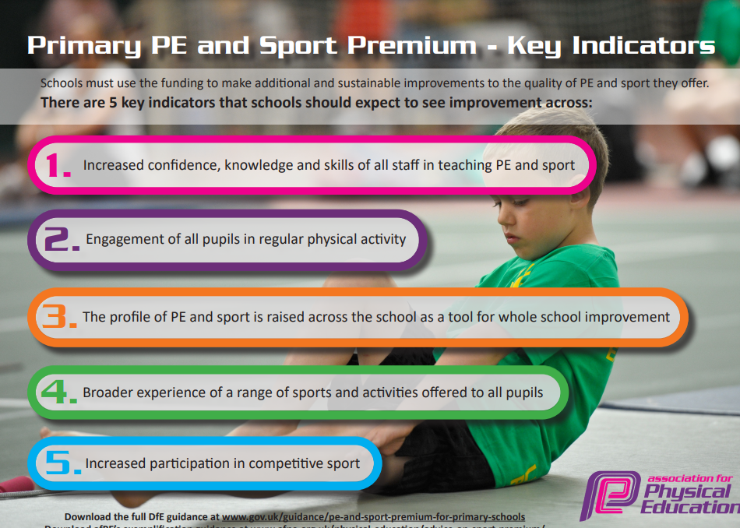

**Key priorities and Planning**

This planning template will allow schools to accurately plan their spending.

|  |  |  |  |  |
| --- | --- | --- | --- | --- |
| **Action – what are you planning to do** | **Who does this action impact?** | **Key indicator to meet** | **Impacts and how sustainability will be achieved?** | **Cost linked to the action** |
| Give all years a specialist PE activity throughout the year.  **PE Equipment**  Sports Coaches  **GetSet4PE Subscription**  Supporting with after school club  **Swimming**  Transport  **Active Week**  Charity Run | All pupils participating in the lessons and learning life skills along the way.  Reception – Balancability  Year 1 – Yoga  Year 2 – Fencing  Year 3 – Karate  Year 4 – Gymnastics  Year 5 – Bikeability  Year 6 – Swimming/Active Week  **All pupils and adults teaching the lessons.**  To support with the teaching of PE and run lunchtime and after school clubs.  **To support all teaching staff that teach PE. High quality PE lessons that are already planned with equipment lists, lesson plans and video examples for those less confident.**  Wells Hall will support pupils’ access after school clubs with the support of premiums  **All pupils participating in the swimming lessons.**  All pupils and adults participating in activities off the school site.  **All pupils at Wells Hall, along with other local schools and their pupils joining us.**  All pupils and staff members | Key indicator 2 and 4  **Key indicator 1,2,3 and 4**  Key indicator 2,3 and 4  **Key indicator 1,2 and 5**  Key indicator 2,3,4 and 5  **Key indicator 2,3 and 4**  Key indicator 2,3,4 and 5  **Key indicator 2,3,4 and 5**  Key indictor 2,3 and 4 | All pupils will be given the opportunity in their year groups to participate in a specialist activity that also has a pathway to follow outside of school.  **All teachers have access to all the equipment throughout the school to ensure that high quality PE lessons are taught**  All pupils will have access to the clubs that are run at lunchtime and then parents can sign up for the after-school clubs.  **GetSet4Pe has been used for PE lessons at Wells Hall for over 4 years now and the improvement in teaching has vastly improved. Teachers feel confident teaching PE.**  Pupils will have access to clubs through the support of the school and giving them the opportunity to participate in sport outside of school and stay active.  £1480  **Years 5 and 6 will take part in 2 terms worth of swimming lessons to increase water confidence, learn life essentials skills and improve their swimming strokes.**  £1000  Pupils will have access to competitions and year 4 gym sessions to Sudbury Gym club.  £1750  **Active Week has been running since 2018 and grows bigger each year. In 2023 we had 700 children from 7 schools take part. 2024 we are aiming to go bigger with more schools joining us. This impacts the wider community as more children get involved in new activities and have pathways to follow outside of school**  £2500  Wells Hall to participate in a charity run for Cancer Research UK | 5700  £1,500  4575  £473 |

**Key achievements 2023-2024**

This template will be completed at the end of the academic year and will showcase the key achievements schools have made with their Primary PE and sport premium spending.

|  |  |  |
| --- | --- | --- |
| **Activity/Action** | **Impact** | **Comments** |
| Active Week 2024  **Swimming**  Active Suffolk Primary School of the Year nomination  **Gold Mark for Sports**  Mini London Marathon  **An increase in after school participation** | Over 450 children participated daily with 15 schools involved  **Our year 5s and 6s participated**  Pupil exposure of the hard work at Wells Hall and keeping pupils active  **Exposure of the school as a leading example.**  Pupils given the opportunity to participate in a charity fun run in aid of Cancer Research UK  **All pupils at Wells Hall** | Active week was a huge success with 15 schools joining us throughout the week and participated in 28 different activities throughout the week. We had 1800 children active throughout the week and gave them pathways to follow outside of school  **We have seen an increase and desire to learn in our swimming lessons with some children able to swim 10m unaided along with over 80% of children able to swim 25m.**  Wells Hall finished runners up in 2023 Active Suffolk Primary School of the Year awards for our commitment to keeping children active, noted for our extra curriculum activities.  **Wells Hall was once again awarded the Gold Mark for their commitment to keeping children active, participating in competitions and high-quality PE lessons. We are aiming for Platinum.**  All pupils and staff members at Wells Hall participated in a mini London Marathon in aid of Cancer Research. Pupils were able to walk, run, jog, hop 2.6km around our school field, we raised over £4000  **We have seen 75% of students involved.** |

**Swimming Data**

*Meeting National Curriculum requirements for swimming and water safety.*

*Priority should always be given to ensuring that pupils can perform safe self-rescue even if they do not fully meet the first two requirements of the National Curriculum programme of study*

|  |  |  |
| --- | --- | --- |
| **Question** | **Stats:** | **Further context**  **Relative to local challenges** |
| What percentage of your current Year 6 cohort can swim competently, confidently and proficiently over a distance of at least 25 meters? | 82% | *This is the first time in 2 years we’ve been able to use our local pool due to reasons outside of our control.* |
| What percentage of your current Year 6 cohort can use a range of strokes effectively [for example, front crawl, backstroke, and breaststroke]? | 83% | *We have seen a vast increase in the number of children that have learned new strokes and practiced them within our swimming lessons. We have moved on from using floats to swimming unaided. This has also been possible to children have free access to the swimming pool outside of school hours due to free swimming sessions provided from our relationships.* |

|  |  |  |
| --- | --- | --- |
| What percentage of your current Year 6 cohort are able to perform safe self-rescue in different water-based situations? | 56% | *Our confident and experienced swimmers were given the opportunity to participate in a lesson of life saving skills.* |
| If your schools swimming data is below national expectation, you can choose to use the Primary PE and sport premium to provide additional top-up sessions for those pupils that did not meet National Curriculum  requirements after the completion of core lessons. Have you done this? | No |  |
| Have you provided CPD to improve the knowledge and confidence of staff to be able to teach swimming and water safety? | Yes |  |

Signed off by:

|  |  |
| --- | --- |
| Head Teacher: | *R Towns* |
| Subject Leader or the individual responsible for the Primary PE and sport premium: | *Mr Joshua Smith – PE Lead at Wells Hall Primary.* |
| Governor: | *Lily Gore* |
| Date: | *July 2024* |